User Manual

FundAnything

-a Crowdfunding WebApp



Shweta Patil  
StudentID: 800989198

10/02/2017

# FundAnything - A Crowdfunding Web Application **Project Name:** FundAnything - a Crowdfunding WebApp

# **Project Overview:**

We all love to dream and feel passionate about our ideas, but most of us struggle with the execution sometimes due to lack of initiative or sometimes due to insufficient funds. We may have great ideas but implementing ideas, if restricted by capital investment is an unfortunate case.

FundAnything is a Crowdfunding platform where people can participate and run campaigns for their projects to raise money. FundAnything helps them to build the campaign, run it, promote it and enable the creators to collaborate with like-minded people. FundAnything is a global platform that offers the lowest fees in the market for its crowdfunding services. It keeps your personal data safe, respects integrity of intellectual property, also allowing you to market your talent well and harness money from it.

**User Roles:**

1. Innovators
2. Patrons

**User Needs:**

1. **Innovators:**

These are users who:

* have business ideas they want to execute, but lack enough funds.
* like an early feedback from people about their ideas or products, so that they can better cater to the needs of the interested minds who they wish to sell their product to.
* can generate funds and get the early buyers who believe in their products and would wait eagerly for its launch.

1. **Patrons:**

These are users who:

* pursue interests by sharing their ideas and suggestions.
* fund existing interesting projects
* reap the benefits of early customers, prime membership, goodies, etc.
* look forward to partnering, advising in future
* collaborate with like-minded people and encourage the ideas and hep the community grow.

**User Activities: Use Cases**

The Web Application allows Innovators to create campaigns to raise funds and Patrons to fund these campaigns.

* Landing Page includes link to sign in and sign up. It also displays active campaigns – **top 5 which need the maximum funds** to attract new users.

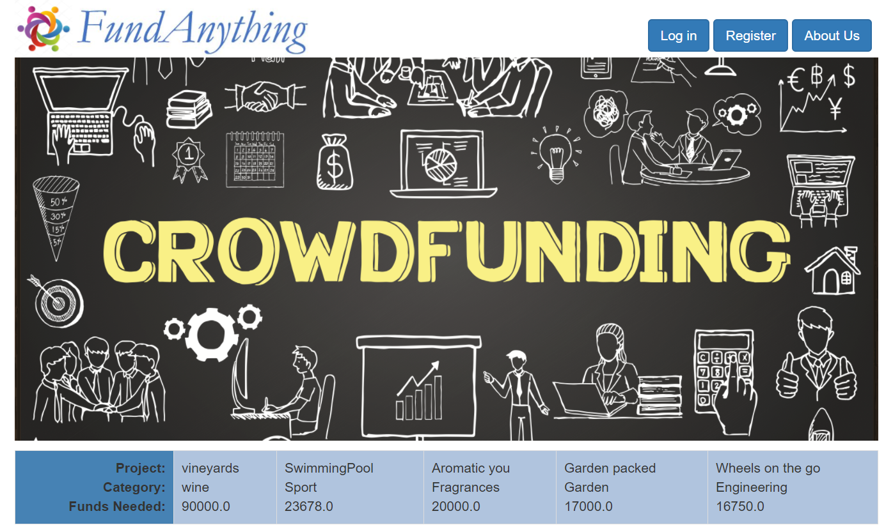

* Users – Innovators and Patrons – can **Build their profiles** on application during signup to advertise themselves better.

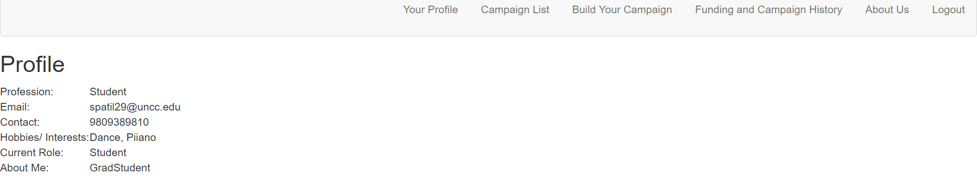

* An **Innovator** logs in using “**Log In**” button on the landing page and login using his valid credentials. If the Innovator is a new user, he can sign up with FundAnything.

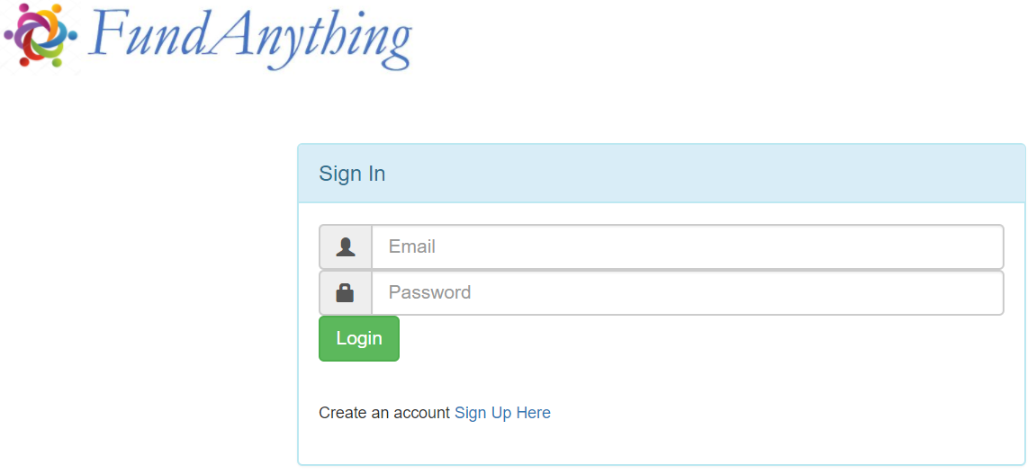

* Once the Innovator logs in, “**Build Your Campaign**” will allow the him to create a project and build a campaign.

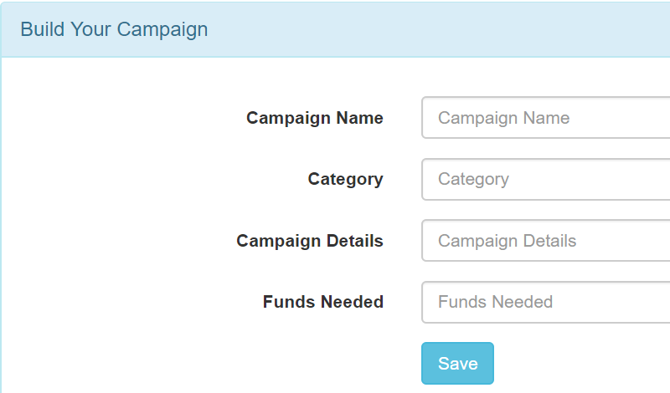

* This campaign will be populated in the “**Campaign List**” containing all existing campaigns which is open to all users.

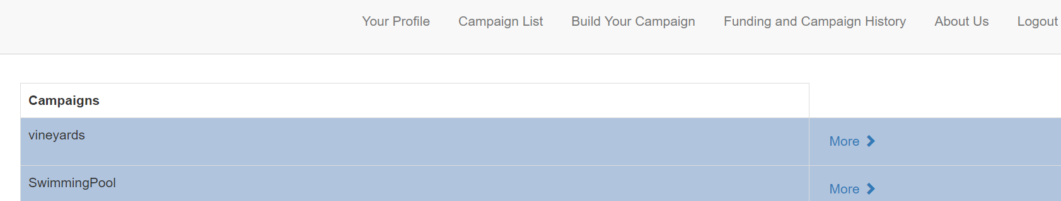

* This campaign will also be added to “**Campaign history**” section of the **History** page for the logged in user.
* An **Innovator** can become a **Patron** by **funding** the existing list of campaigns by choosing from the **Campaign List** page available only after logging in to the application. He can choose the campaign of interest from the available campaigns in the campaign list and choose “More” to see available options.
* Details of the campaign will be displayed. He can **email** the innovator for any queries, and further communication will take place in the user’s gmail/yahoo, etc. mailboxes.

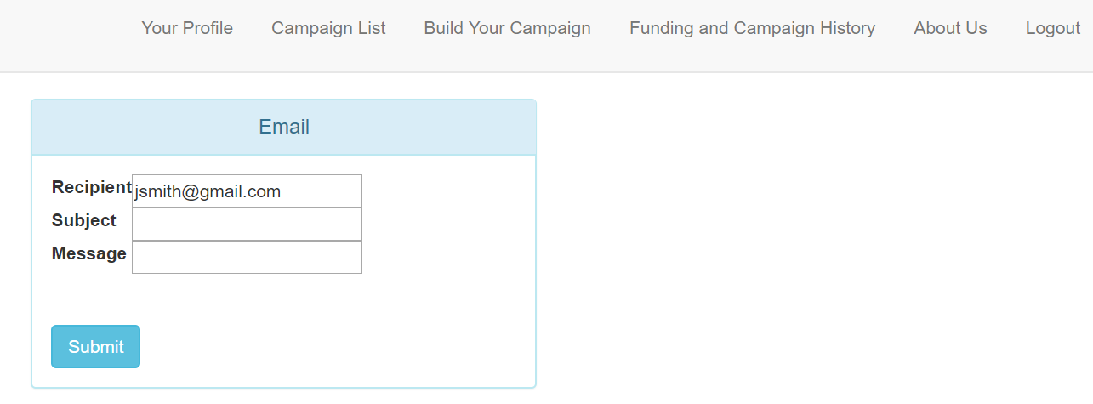

* He can enter a **funding amount** in the available textbox and click on “**Fund this campaign”**. On submitting funds, a success message will be shown to indicate successful funding event. In case of any issues, an error message will be displayed.

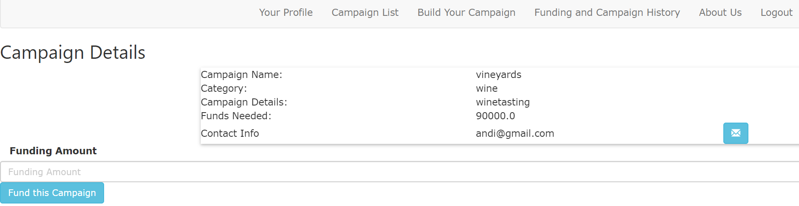

* A **Patron** can initiate his own campaign and become an Innovator. After the Patron has logged in, he will be made available an option to build his own campaign and broadcast it to the users of the website. “**Build Your Campaign**” allows the same.
* All funding activities for **Patrons** will be logged in the “**Funding History**” section of the **History** page. History page is available on login and will load data if you have funded any of the existing campaigns.

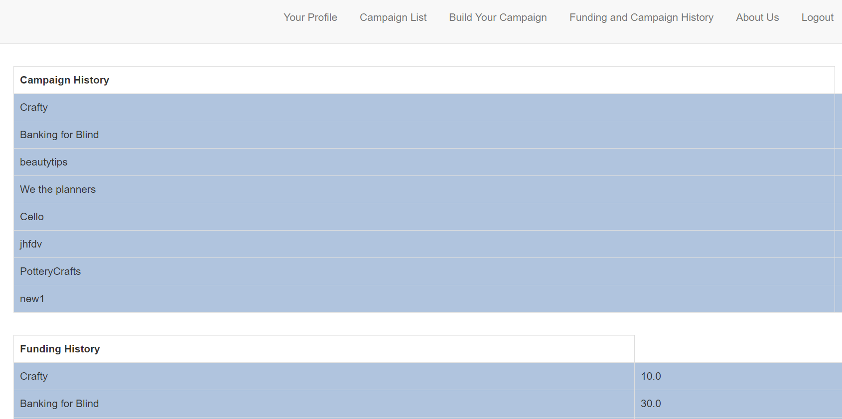

**Logout:**Users can log out at any point of time during their session in the application.

* Logging out will prevent any further action on the web pages of the application.
* A user who is not logged into the application does not have any access to any campaign details whatsoever.

**About Us:**

* About Us page gives information about our initiative and encourages new users to join our growing community.
* It holds details of contacting with us for any queries or grievances